2.

(1) $\frac{1}{1+e^{-z}}-\frac{e^{-z}}{1+e^{-z}}>0, so e^{-z}<1, so z>0$

$\left\{ X\right|1+2x_{1}+3x_{2}>0\}$

(2) $\frac{1}{1+e^{-z}}>0.8, so e^{-z}<\frac{1}{4} , so z>ln4$

$\left\{ X\right|1+2x_{1}+3x_{2}>ln4\}$

(3) $z>ln4$, so $1+2x_{1}+3x_{2}>ln4, and x_{2}=0.5, so x_{1}>(ln4-2.5)/2$

$\{X|x_{1}>(ln4-2.5)/2$}

3.

(1) 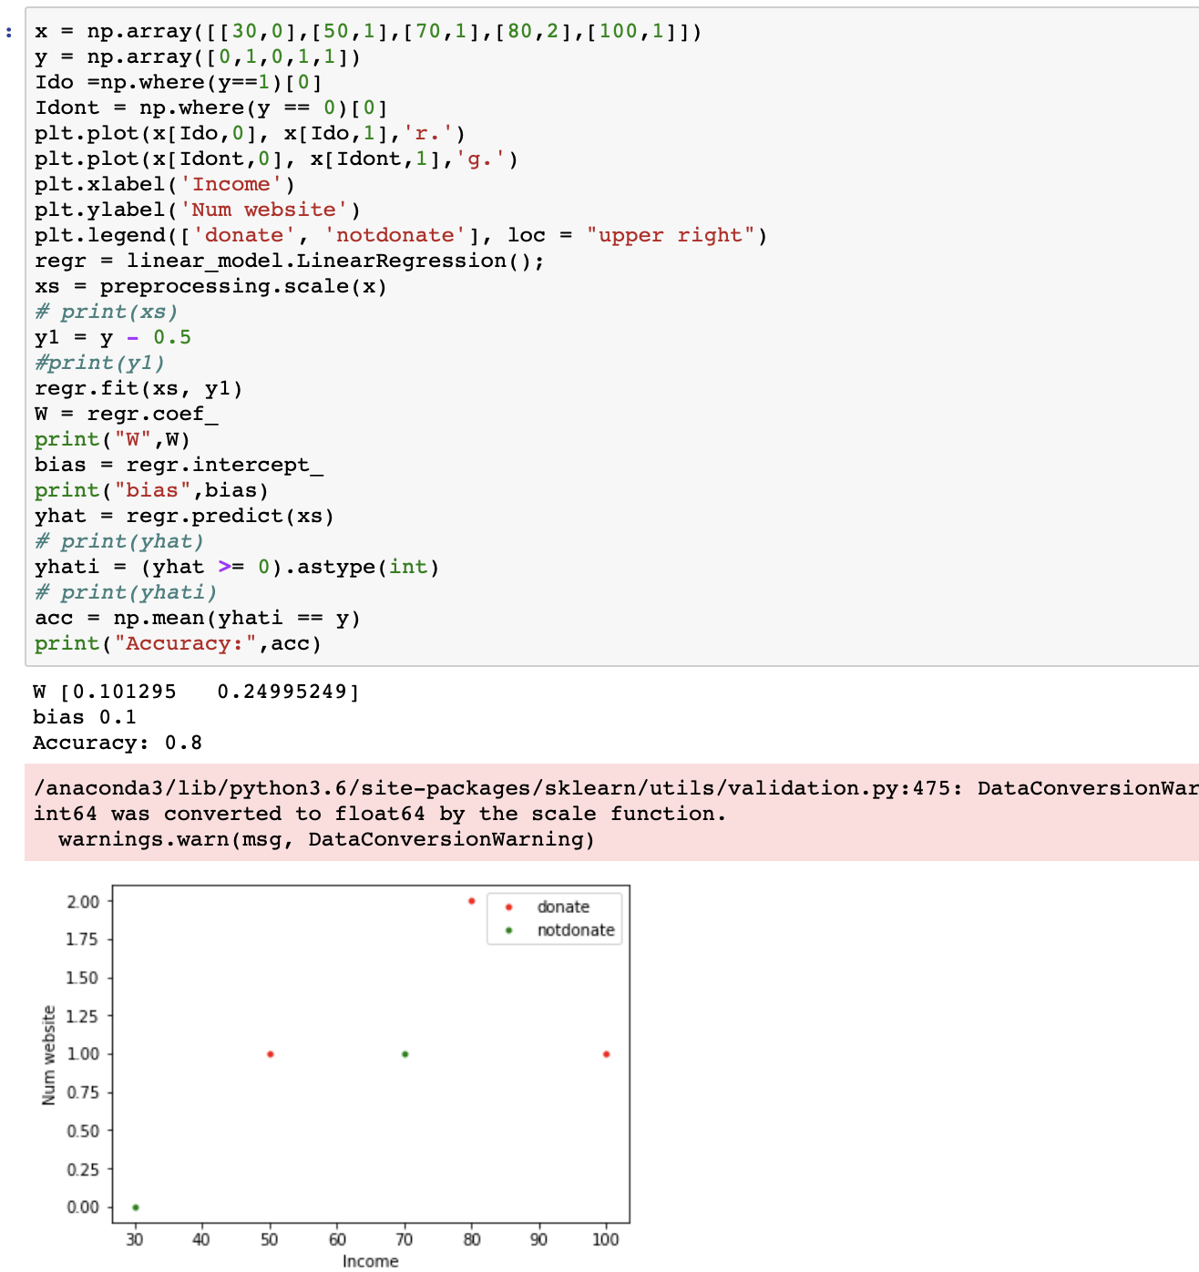

(2)

if P is the smallest, then z should be the smallest, so sample 0 make it least.

(3)

In part(b), it doesn’t change anything, because in that way, new z will be $α$ multiple of the previous z , but $α$ is positive, so sign of new z is the same with the old z, so they do not change.

In part(c), P will become larger than previous which means in this calculation, it shows the more people are willing to donate money.

4. $z=β_{0}+β_{1}x_{1}+β_{2}x_{2}$

(1) z = -0.5 $p=\frac{1}{1+e^{\frac{1}{2}}}$

(2) p = 0.5, so z = 0, so hours = 50